英语 八年级下册
Unit 5 | What were you doing when the  rainstorm came? | Period 2 | Content Section A 3a, 3b, 3c
教学目标要求
1．能够讨论过去的事情：What were people doing yesterday at the time of the rainstorm? 等。
2．能够表达过去某一时刻正在做的事情：Ben was helping his mom make dinner when the rain began to beat heavily against the windows.
3．能掌握日常生活中的一些动词beat; realize; report; rise; fallen等。
4．能够学会用when, while表达某动作、某事件发生的时间: Ben’s dad was putting pieces of wood over the windows while his mother was making sure
the flashlight and radio were still working. 等。
5．能够讲述过去的事情：She also put some candles and matches on the table. 等。
6．能认读并能工整书写所学居家生活词汇：storm, wind, light, wood, window, match, flashlight等。
7．能模仿录音正确朗读和表演教材上的课文。如：The storm brought people closer together.
教学过程
活动 | 步骤 | 教与学活动目的及其操作 | 教学资源运用
复习  时间  2 m | 1 | 复习已学目标语。  展示图片，并就图片内容提问学生。  图片一：What was the boy doing at 6 yesterday morning?  图片二：What was the girl doing at 7 last night?  图片三：What was the man doing at 8 yesterday morning? | 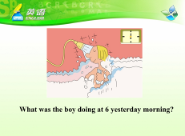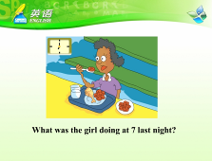  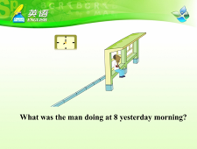
导入  时间  3 m | 2 | 引入本课话题。  Now, look at another picture. What can we see in the picture? (学生回答：house, broken house等)It is a picture taken after a storm. The house was broken in the storm. (讲解storm) Because the wind was too heavy. (讲解wind)  引导学生观察图片并导入本课课文标题。 | 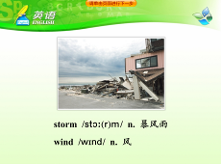
3a  时间  10 m | 3 | 导入本课标题。  Today, let’s learn an article about storm.  教师边说边将3a课文标题写在黑板上：  The Storm Brought People Closer Together
3a  时间  10 m | 4 | 提问问题，猜测本课内容。  Look at the title.  What does it mean?  What will storm do to us?  Will storm do good or do harm to us?  How can storm bring people closer?  学生自由回答，充分想象。 | 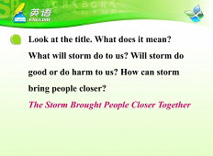
3a  时间  10 m | 5 | 根据标题和图片猜测并概括文章大意。  Now, guess the main idea of the passage according to the title and the picture and write it down.  学生根据图片和题目猜测文章大意并用一句话概括。 | 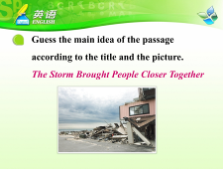
3a  时间  10 m | 6 | 快读课文，初步了解文章。  Now read the passage quickly.  学生快速阅读。  教师提问：  — Were winds strong or weak?  — Strong!  — Were clouds black or white?  — Black.  — Was the sky dark or bright?  — Dark.  — Did neighbors stay inside or clean up outside?  — They cleaned up the neighborhood outside.  — Is everything in a good order or in a mess?  — In a mass.  — How are windows? Are they good or broken?  — Broken.  — Where is rubbish?  — Everywhere.  — Can you see fallen trees?  — No, we can’t.
3a  时间  10 m | 7 | 仔细阅读，了解文章细节。  Read the passage carefully and answer the questions.  核对答案。 | 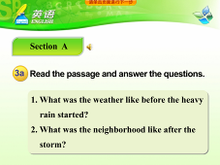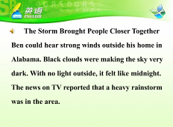  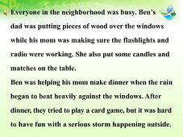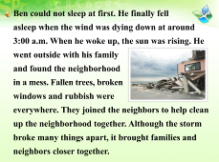  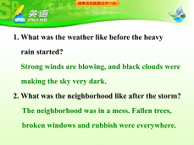
3b  时间  8 m | 8 | 默读课文，巩固对文章内容的理解。  Read the passage silently and complete the sentences in 3b.  让学生默读课文完成3b并核对答案。 | 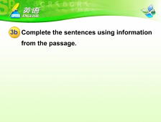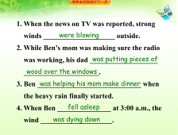
3b  时间  8 m | 9 | 比较句子，进一步加深对文章的理解。  Find out the sentences in the passage and compare them.
3c  时间  7 m | 10 | 阅读后提问，为小组讨论做铺垫。  Look at the sentence “Although the storm broke many things apart, it brought the families and neighbors closer together.”  What other things can bring people closer together? (学生可能会说火灾、地震等)根据学生的回答，教师适当添加一些词语并板书。例如: fallen house, fallen stones, no water, no light, no food, break the roads apart, break the bridges apart。 | 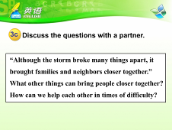
3c  时间  7 m | 11 | 分组讨论，巩固目标语并加以拓展。  Now, let’s talk about “What can we do to help others in this case?” in groups.  小组讨论，每个小组由发言人起来汇报讨论结果。
小结  时间  2 m | 12 | 总结本课所学目标语。  让学生跟读课文。
拓展  时间  7 m | 13 | 拓展：训练学生组词成句的反应速度；深入强化课文内容。  1．教师课前准备十六张硬纸充当纸牌。  2．每四人一组，每人发给四张牌，每张牌上写有单词和词组。  3．一个人出自己手上的任意一张牌。其他三人出的牌要能  和第一张牌组成一个完整的句子，谁错了，谁出局。换  人重新来，一直没出局的是赢家。  4．这四组牌是这样分的：S1手上的牌是：  1．black clouds 2．the storm 3．the trouble  4．Ben (其他三人按下表分.  5．他们组出来的句子是以下四句来自课文的句子。
  S1 | S2 | S3 | S4
  Black clouds | made | the sky | dark
  The storm | broke | many things | apart
  The trouble | brought | neighbors | together
  Ben | found | the neighborhood | in a mess
作业  1 m | 14 | Homework(布置作业)  1．听课文3a录音并进行模仿朗读。  2．小组讨论What can we do to help others after the storm?  并把结果记录下来。 | 